**Help Section**

**Introduction**

1. To Start of your transaction Kindly select the location of the file that you will be printing.
2. You have two option in accessing your document.

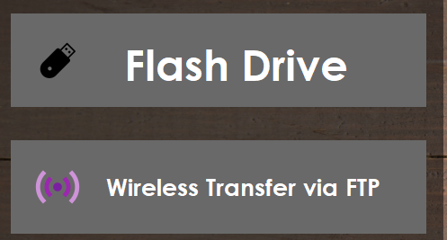

* 1. **Flash Drive** here you can access the file located in an external device
  2. **Wireless Transfer** here you can access your file via FTP.

**Flash Drive Procedure**

1. Click the Flash Drive Button

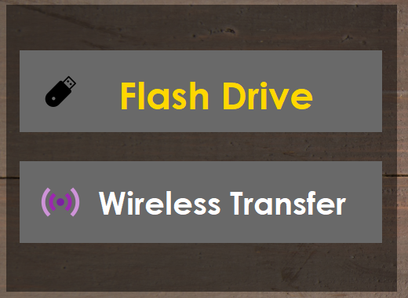

1. Open dialog box will be opened

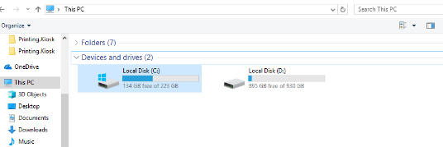

1. Now Find and Select your file and click open. (file format | .pptx , .docx, .doc, xls)

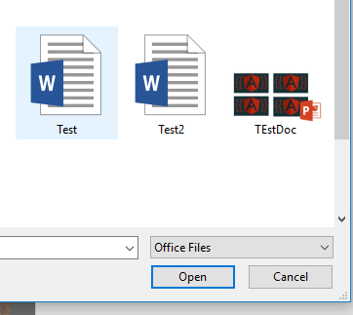

1. 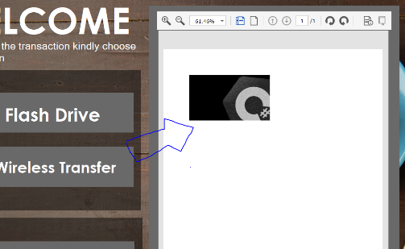Next is your file will be displayed on the right pane of the screen
2. After verifying your document click the print document button.

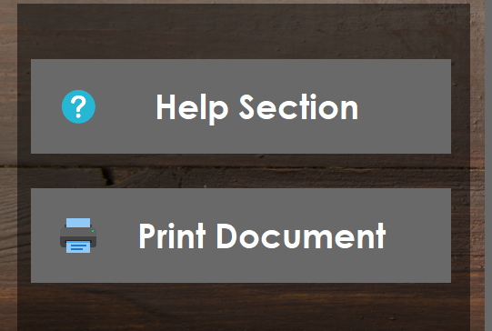

1. Print properties will be displayed and you can set if you want to print in color or not

To print in color just check whether the grayscale button is checked in the properties section.

If Grayscale Is checked then your print out will be B & W if not then its colored

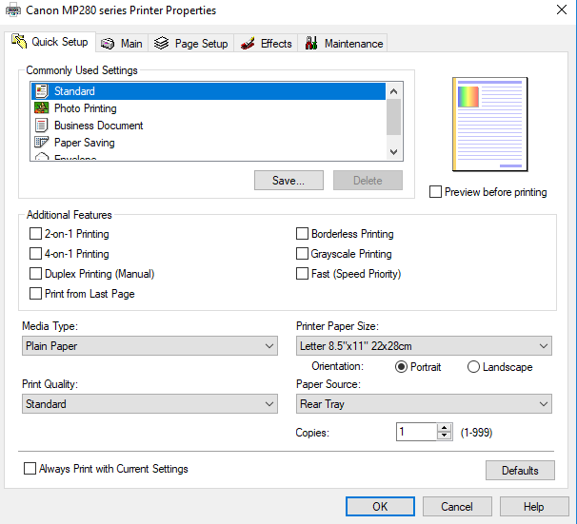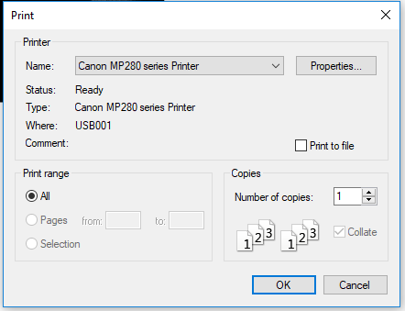

1. 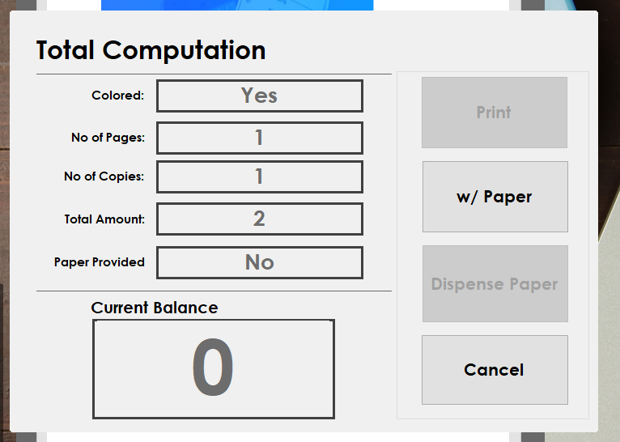Computation summary will be displayed after confirming your setup in Printer Settings. To proceed in printing your document kindly drop the amount equal to the total amount text box.
2. 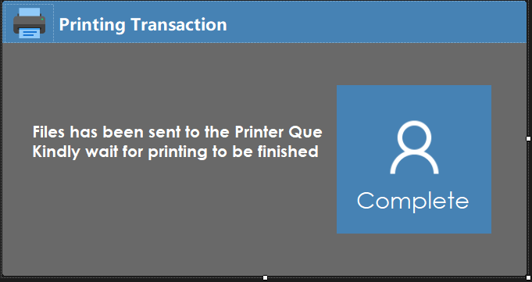If the user has his own paper then kindly press “w/Paper” to disable the Dispenser of paper, if you have already inserted the same amount displayed in the total amount then print button will be enabled and you may proceed in printing your document. A pop up will be displayed saying that your document has been put into the que of the printer.

**Wireless Transfer Procedure**

1. Click the **Wireless Transfer** Button



1. An instruction on how to connect and send your file via WIFI will be displayed

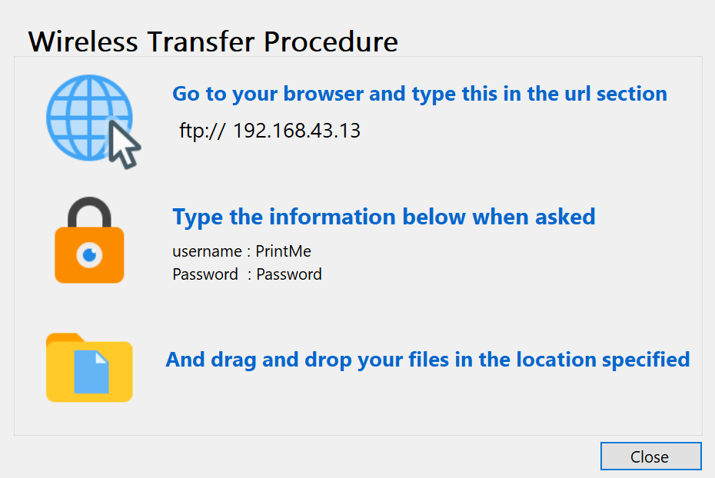

1. Open dialog box will be opened, the first location displayed is the expected location that will be containing your document.

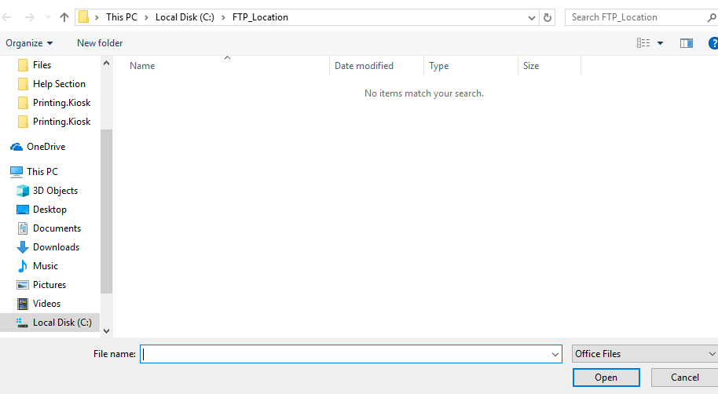

1. After you have selected your document it will be displayed on the right pane corner of the screen.

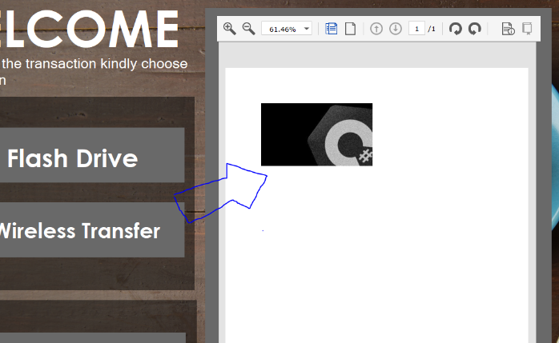

1. After verifying your document click the print document button.



1. Print properties will be displayed and you can set if you want to print in color or not

To print in color just check whether the grayscale button is checked in the properties section.

If Grayscale Is checked then your print out will be B & W if not then its colored



1. Computation summary will be displayed after confirming your setup in Printer Settings. To proceed in printing your document kindly drop the amount equal to the total amount text box.
2. If the user has his own paper then kindly press “w/Paper” to disable the Dispenser of paper, if you have already inserted the same amount displayed in the total amount then print button will be enabled and you may proceed in printing your document. A pop up will be displayed saying that your document has been put into the que of the printer.